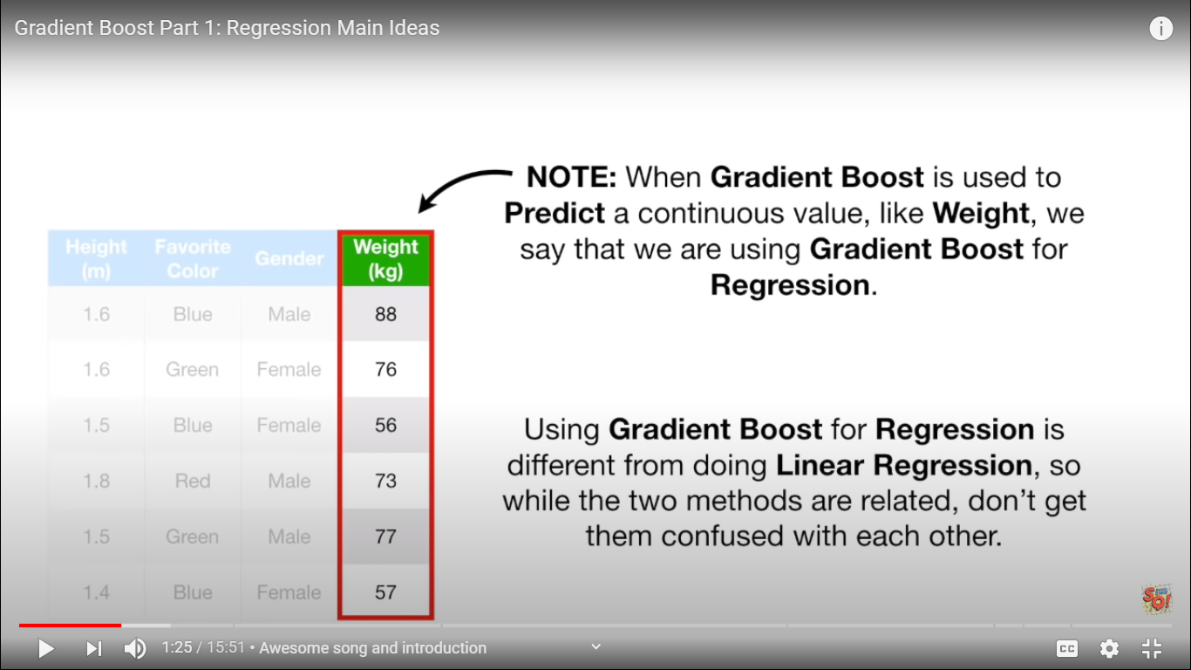

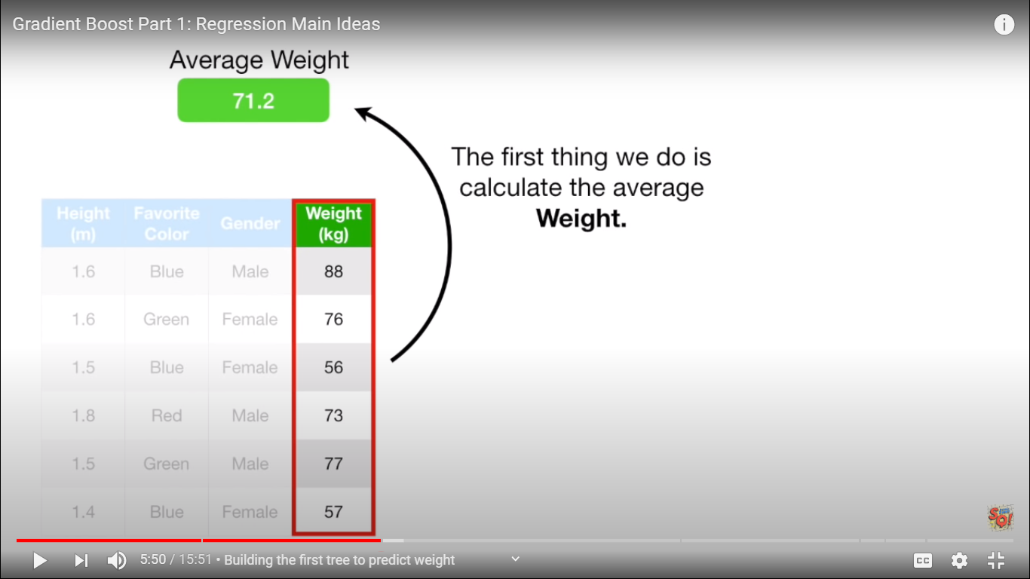

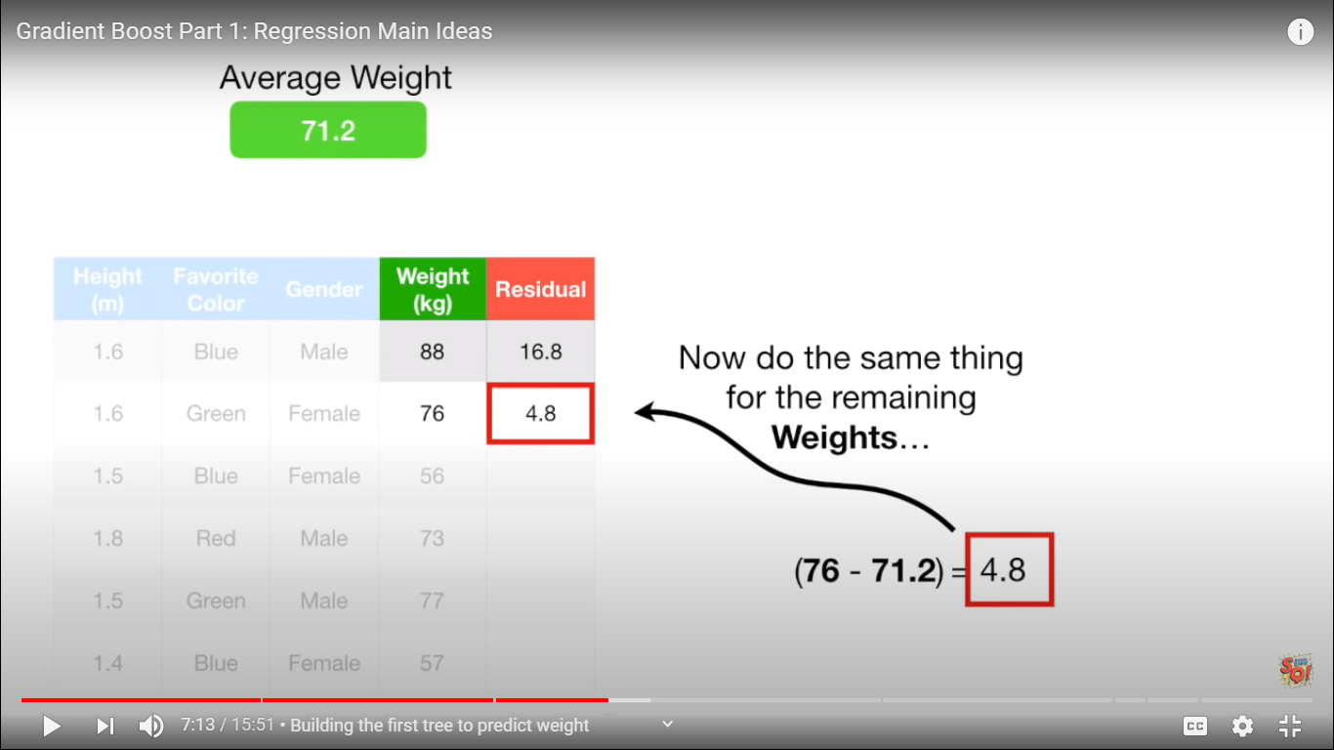

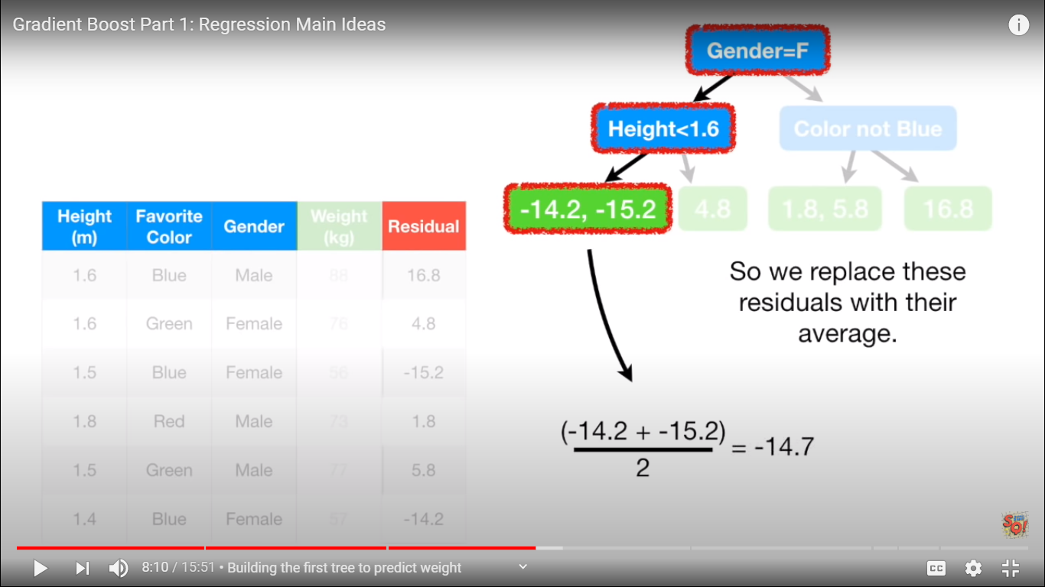

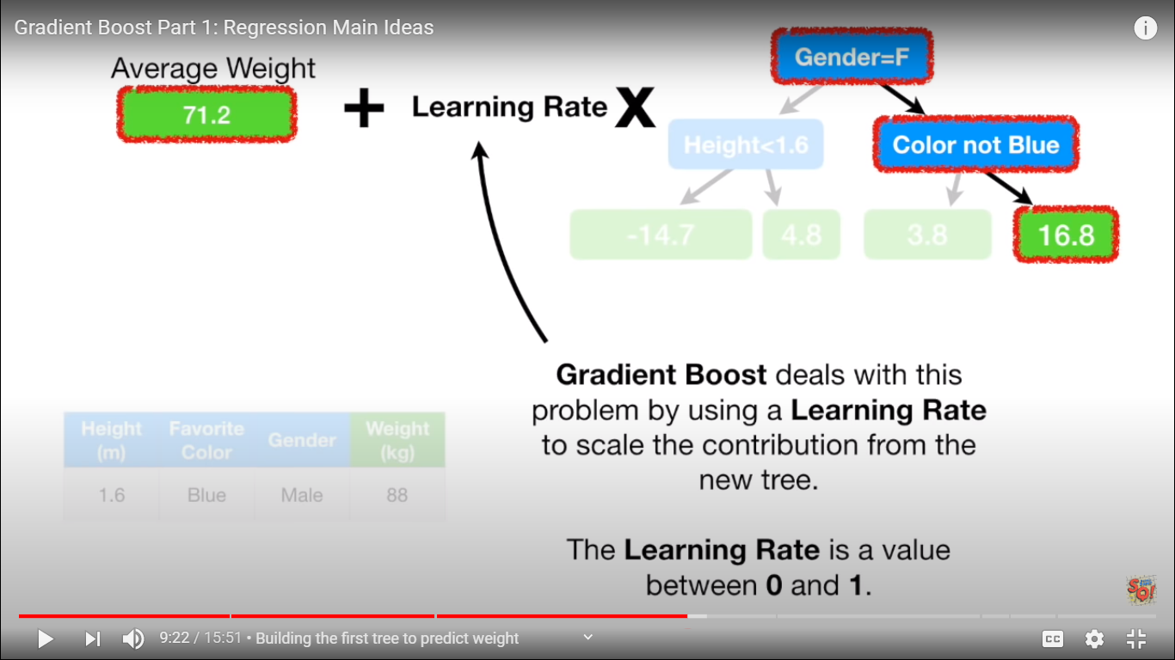

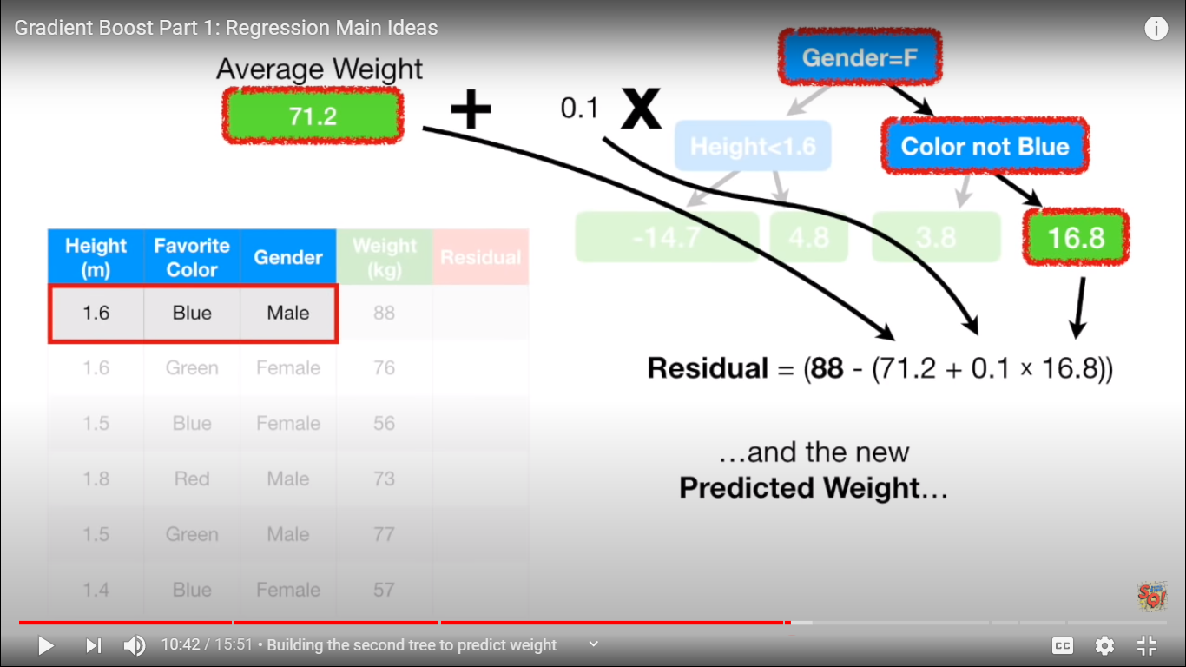

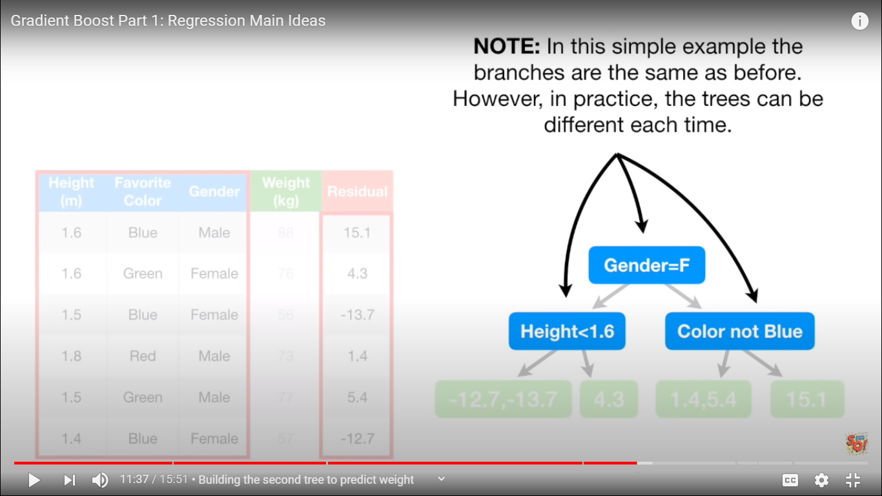

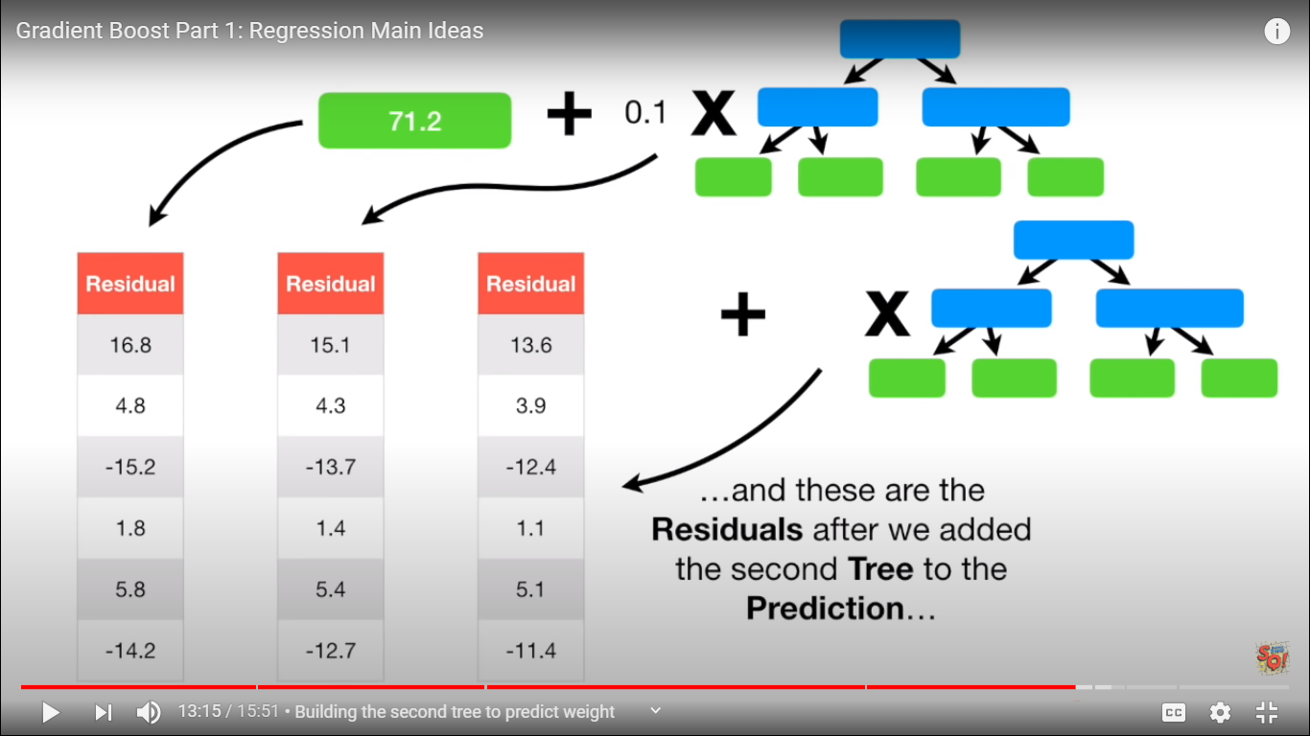

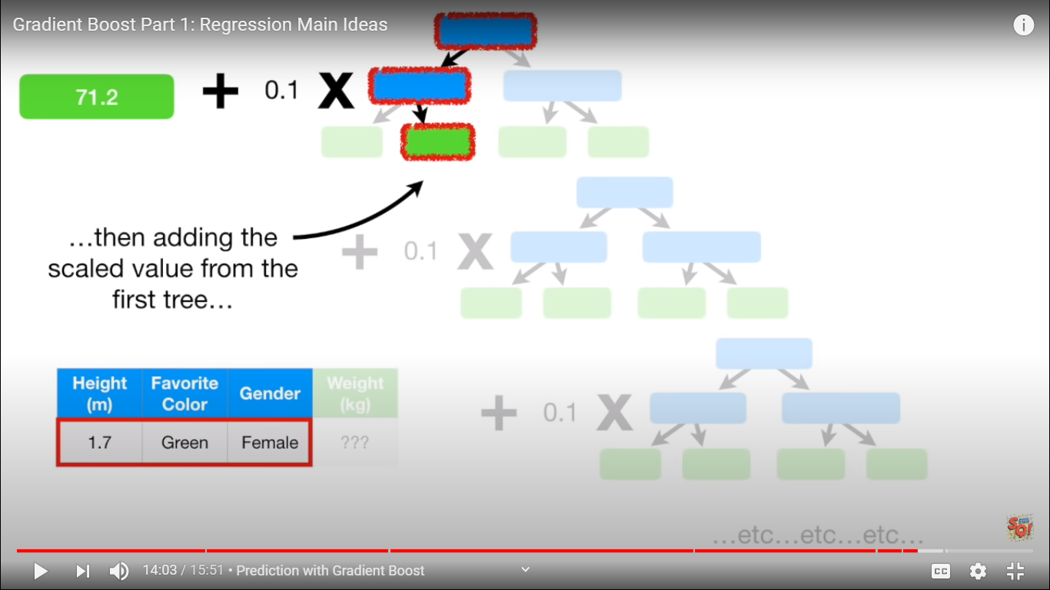

CART vs MART vs DART

**CART – DTREES**

**Adaptive models**

**Additive** tree models

MART **-- GBM** –

**DART** --- dmlc **XGBoost** –

Microsoft LGBM

Open source **CAT**BOOST

<https://arxiv.org/abs/1505.01866>

1. Use of **sparse matrices** with sparsity aware algorithms
2. Improved data structures for better processor **cache utilization** which makes it faster.
3. Better support for **multicore processing** which reduces overall training time.

Data structures – list array matrix…..

Sparse Matrix----COO CRC CRS

<https://docs.scipy.org/doc/scipy/reference/sparse.html>

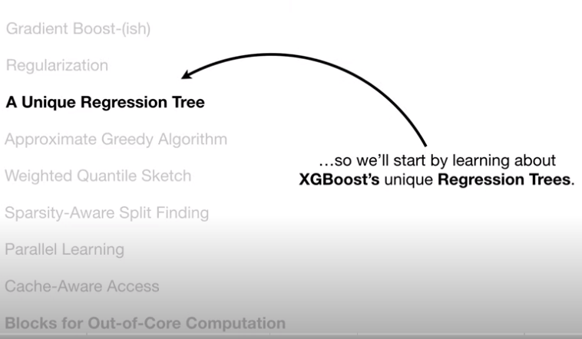

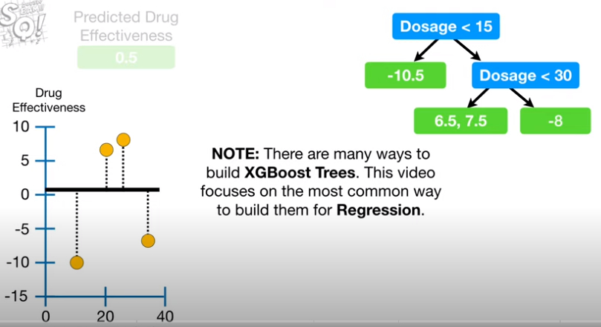

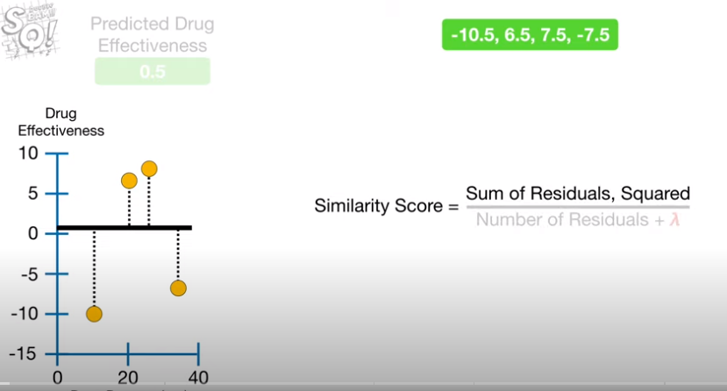

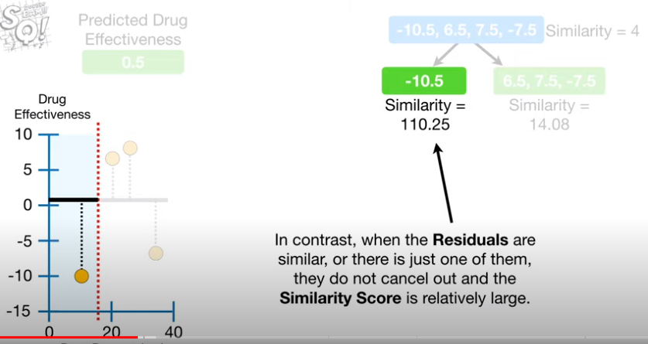

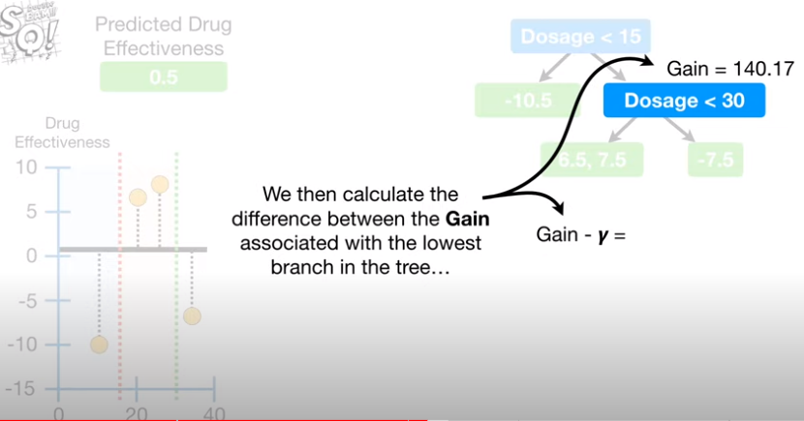

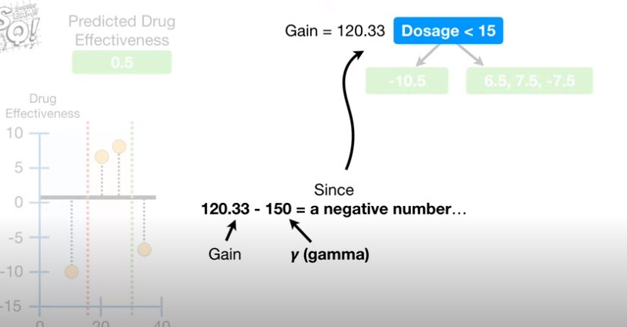

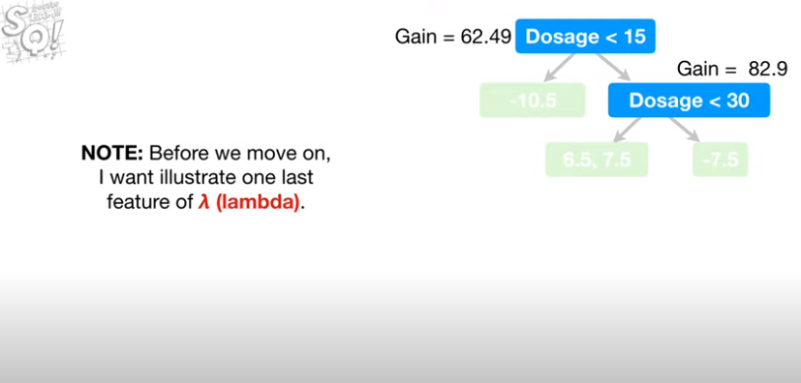

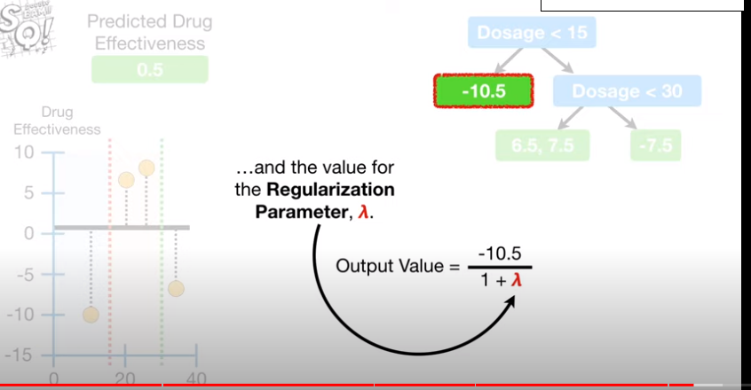

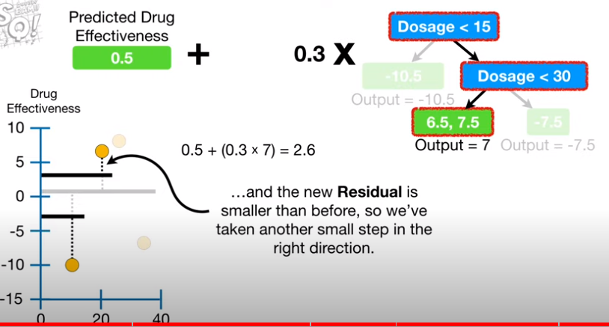



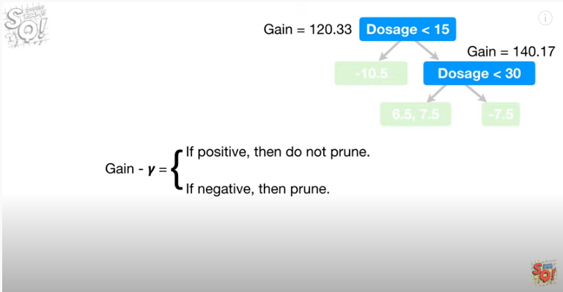

Pip install xgboost

pip install lightgbm

pip install catboost

<https://pypi.org/project/lightgbm/>

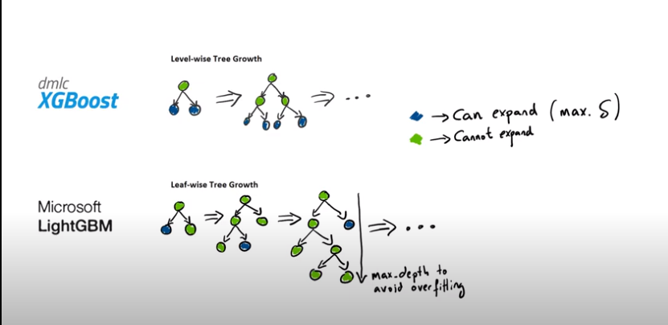

**boosting:** defines the type of algorithm you want to run, default=gdbt

* gbdt: traditional Gradient Boosting Decision Tree
* rf: random forest
* dart: Dropouts meet Multiple Additive Regression Trees
* goss: Gradient-based One-Side Sampling
* [12:54:28] INFO: C:\Users\Administrator\workspace\xgboost-win64_release_1.1.0\src\tree\updater_prune.cc:98: tree pruning end, 38 extra nodes, 0 pruned nodes, max_depth=6

<https://www.youtube.com/watch?v=oGRIGdsz7bM>

